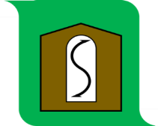 Southam Parish Council

Parishioners are warmly invited to the
ANNUAL PARISH MEETING of SOUTHAM PARISH
taking place in the Village Hall, School Lane, Southam at 7.00PM on Tuesday 12th May 2026. This is your meeting to discuss parish matters. Refreshments will be served after the APM and before the Southam Parish Council AGM which will follow. Reports from the Parish Council, County and Borough Councils will be presented.
Steve Lennon (Chairman, Southam Parish Council)

- Welcome from the Chairman
- A presentation from Cleeve Common Trust – Michael Bates, Clerk, Cleeve Common Trust. Questions from residents are welcome.
- Southam Parish Council Annual Report.
- Gloucestershire County Councillor’s Annual Report.
- Tewkesbury Borough Councillor’s Annual Report.
- Share your views, concerns, and questions with the Council.
- Tea, coffee and biscuits.

The meeting will close at approx. 7.45pm for refreshments, to be followed by Southam Parish Council AGM.

